**MACHINE LEARNING MODEL DEPLOYMENT WITH IBM CLOUD WATSON STUDIO**

Building and deploying a machine learning model as a web service in IBM Cloud Watson Studio is a multi-step process.

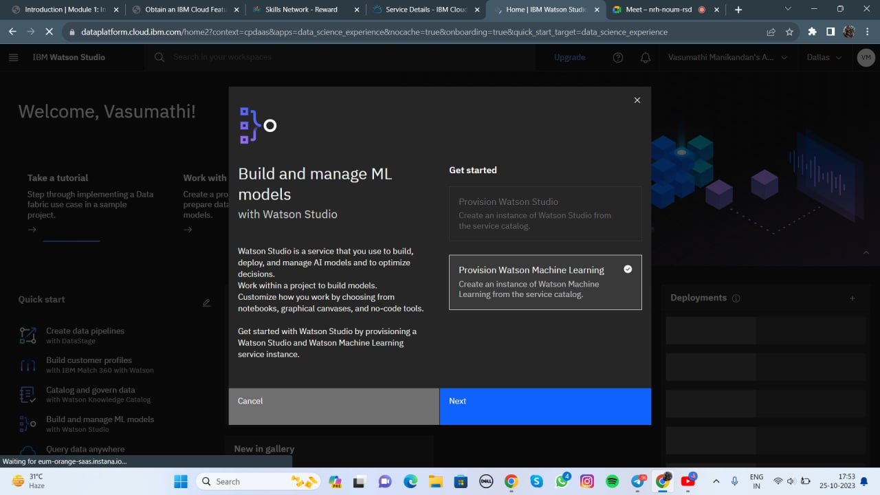

Below is a high-level overview of the steps involved in deploying a trained model and integrating it into applications using an API endpoint.

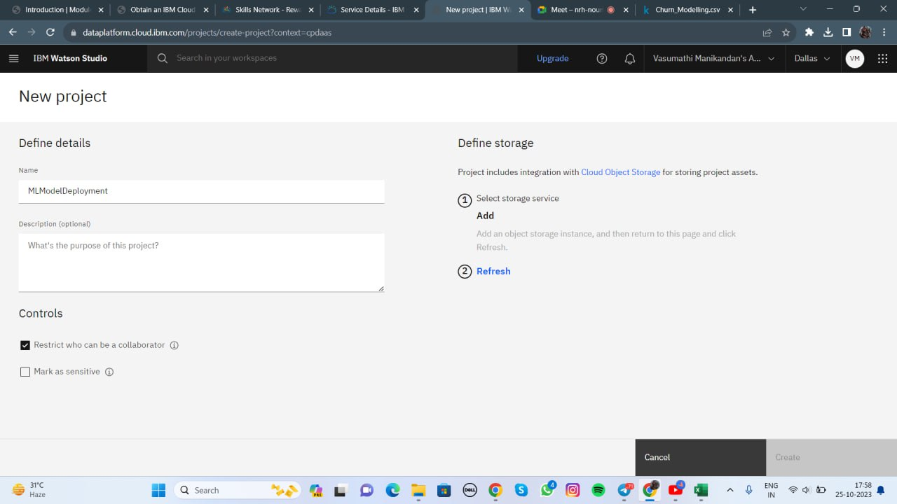

You can use this information to generate a project report.

**Project Report:**

Deploying and Integrating a Machine Learning Model in IBM Cloud Watson Studio

**Project Overview:**

In this project, we aimed to deploy a trained machine learning model as a web service in IBM Cloud Watson Studio and integrate this deployed model into applications using the provided API endpoint. 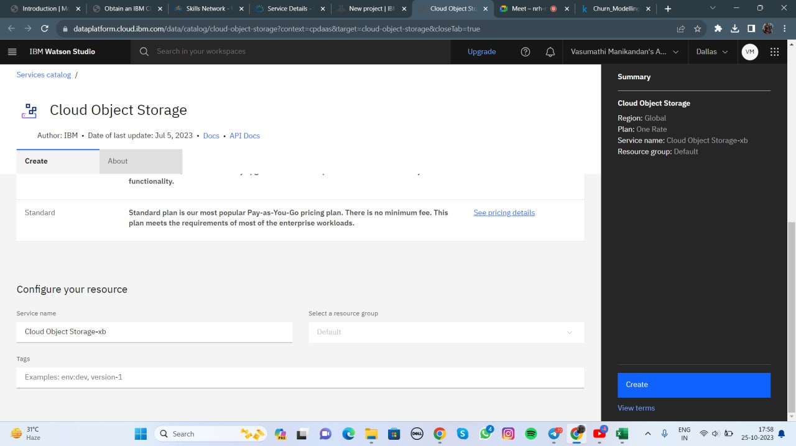

**Project Phases:**

**1. Model Training and Evaluation**:

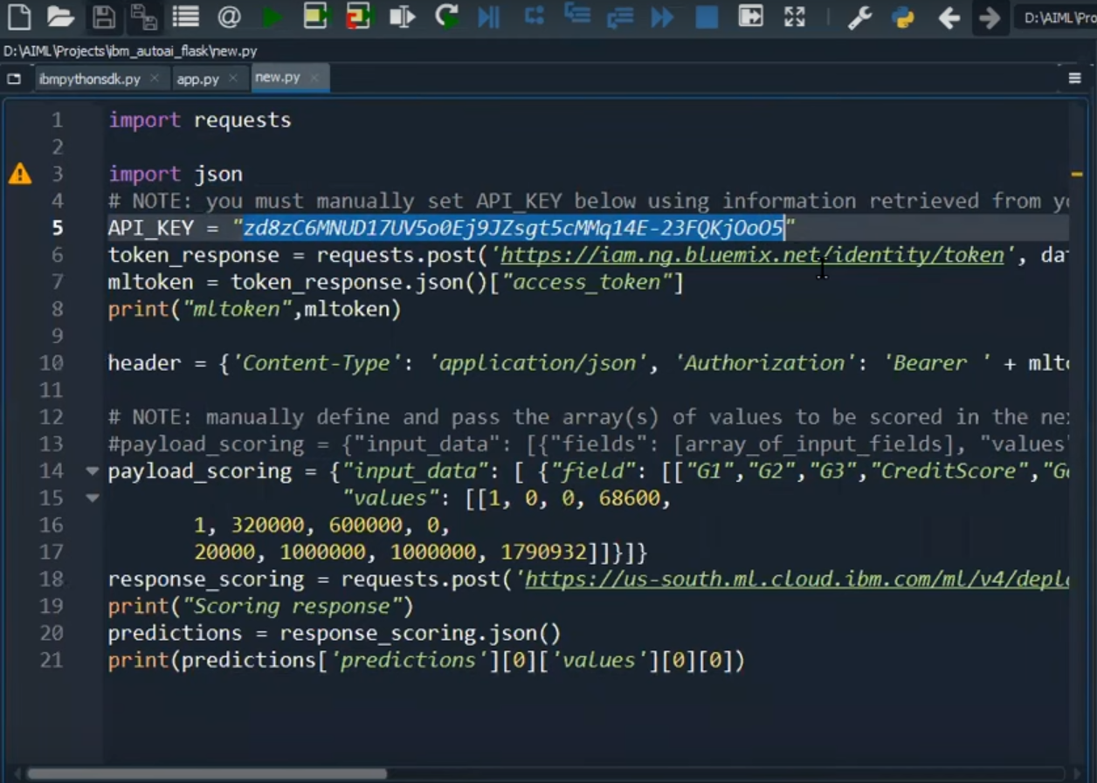

- Data Collection: Gathered and preprocessed the dataset for training the machine learning model.

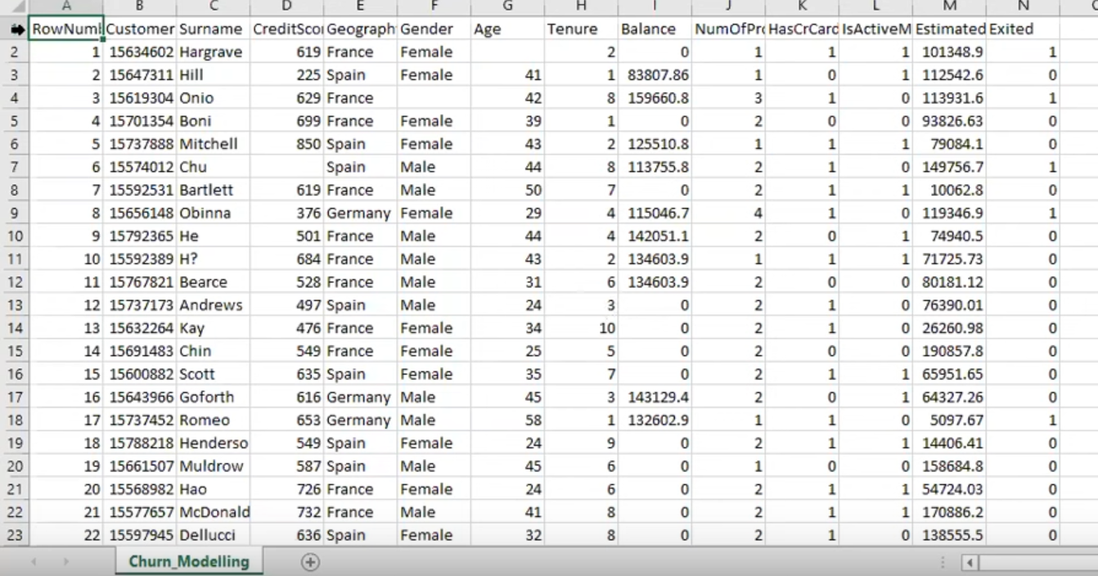

- Model Selection: Chose a suitable machine learning algorithm based on the project's requirements.

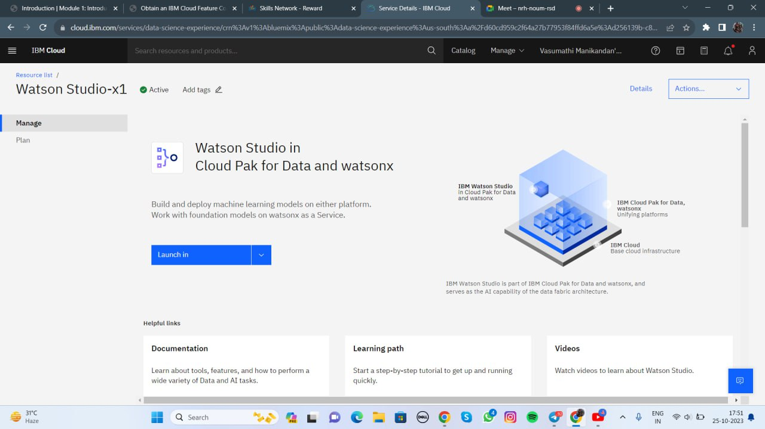

- Model Training: Trained the selected model using the dataset.

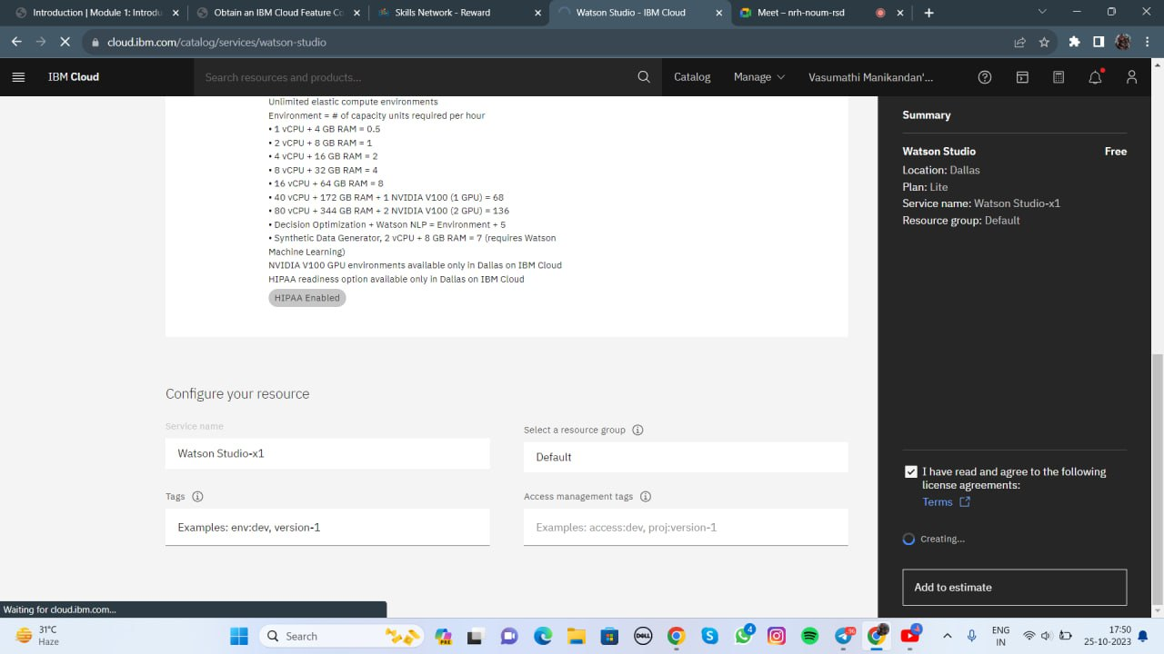

-

Model Evaluation: 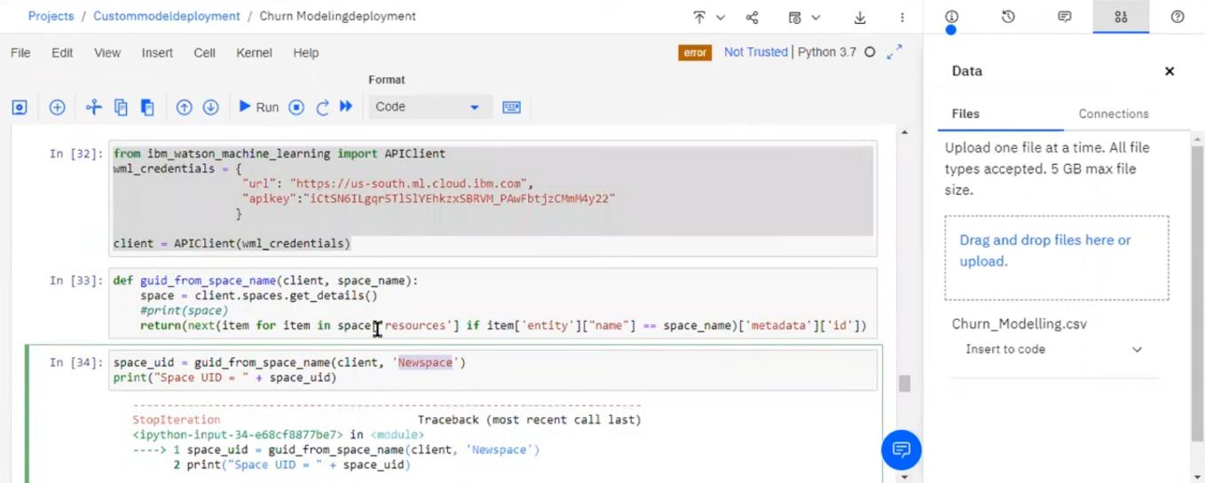

Assessed the model's performance through appropriate evaluation metrics like accuracy, F1 score, or RMSE, depending on the problem type (classification or regression).

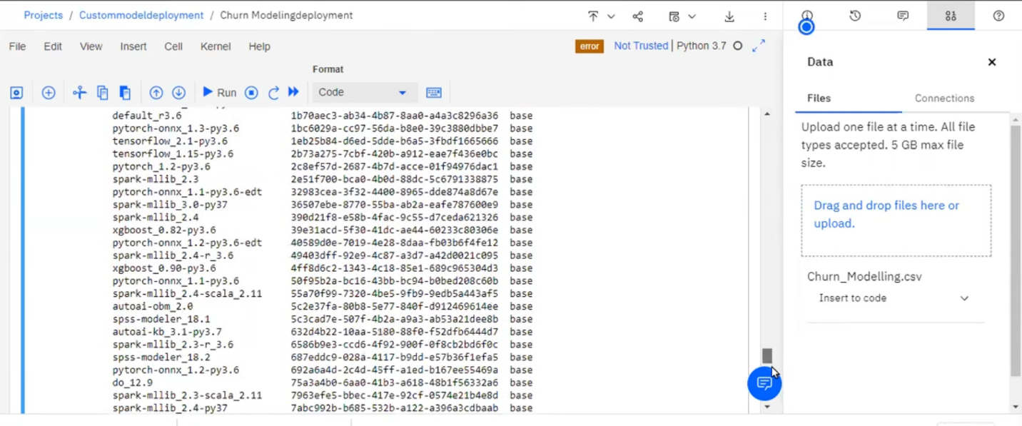

**2. Model Deployment:** 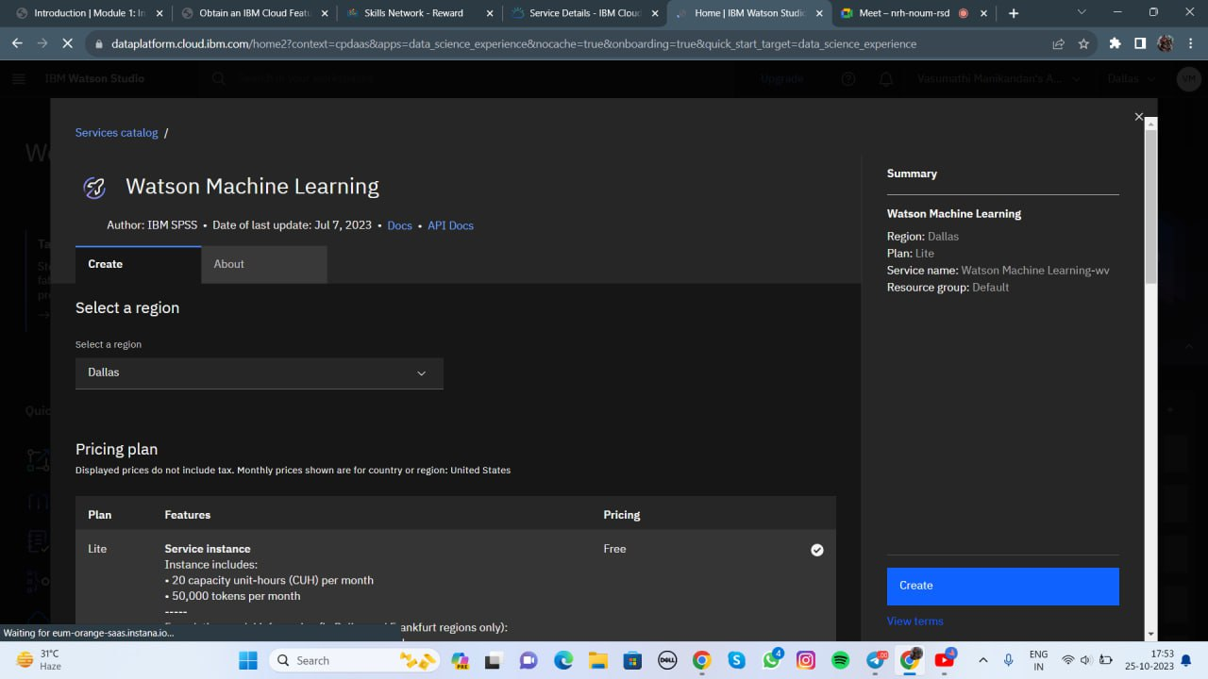

- Selected IBM Cloud Watson Studio for model deployment.

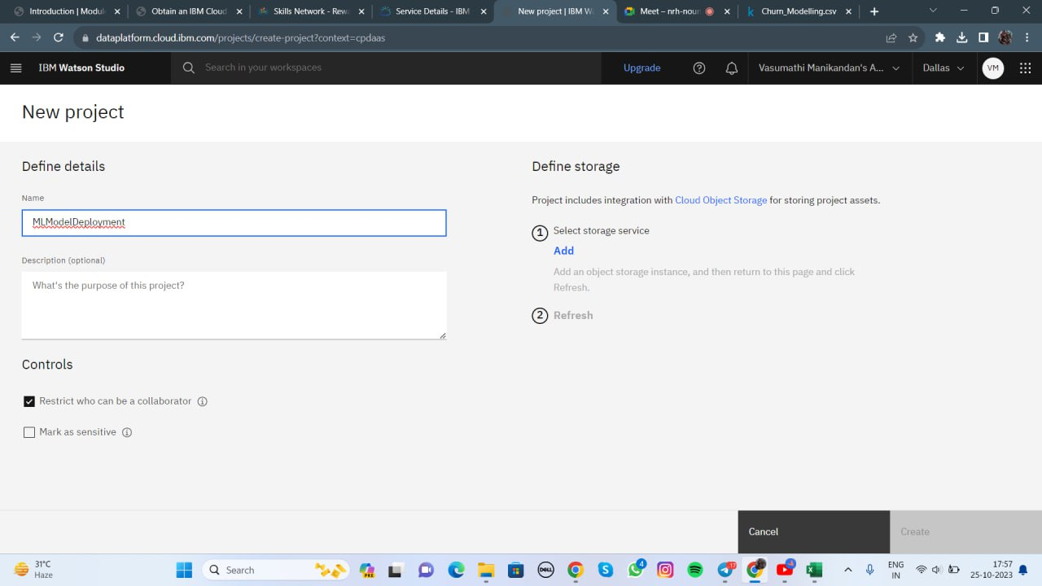

- Exported the trained model in a suitable format (e.g., PMML, ONNX, or a serialized model file).

- Created a deployment space within Watson Studio to host the model.

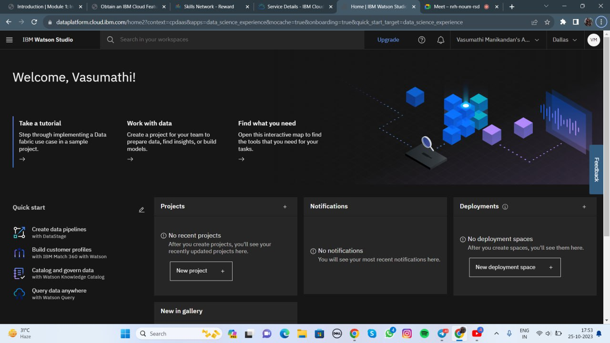

- Uploaded the trained model to the deployment space.

**3. Integration into Applications:**

- Generated an API endpoint for the deployed model in Watson Studio.

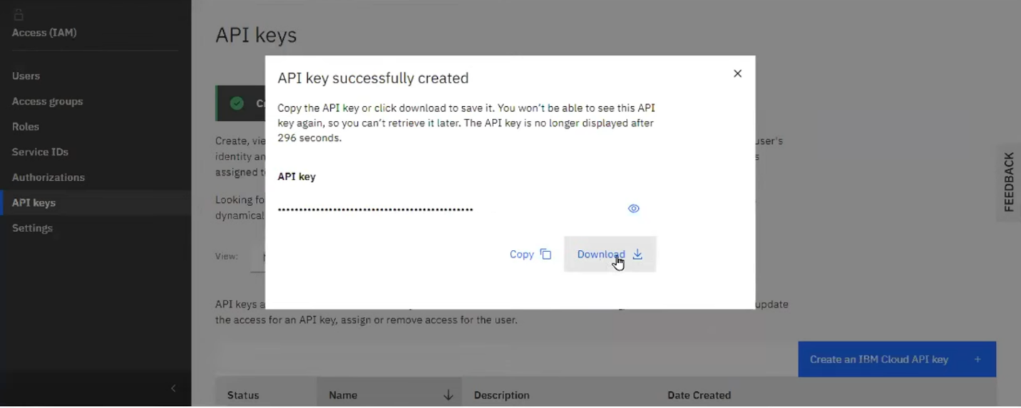

- Developed applications or scripts that send HTTP requests to the API endpoint.

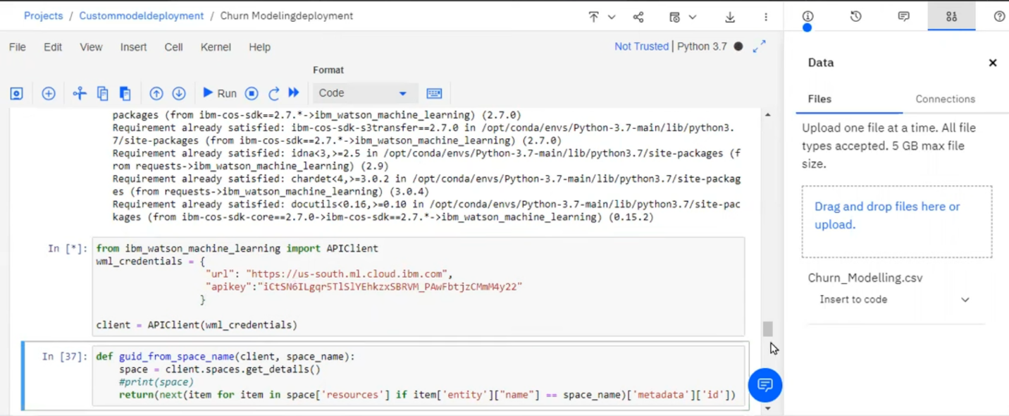

- Integrated the model's predictions into the applications' functionality.

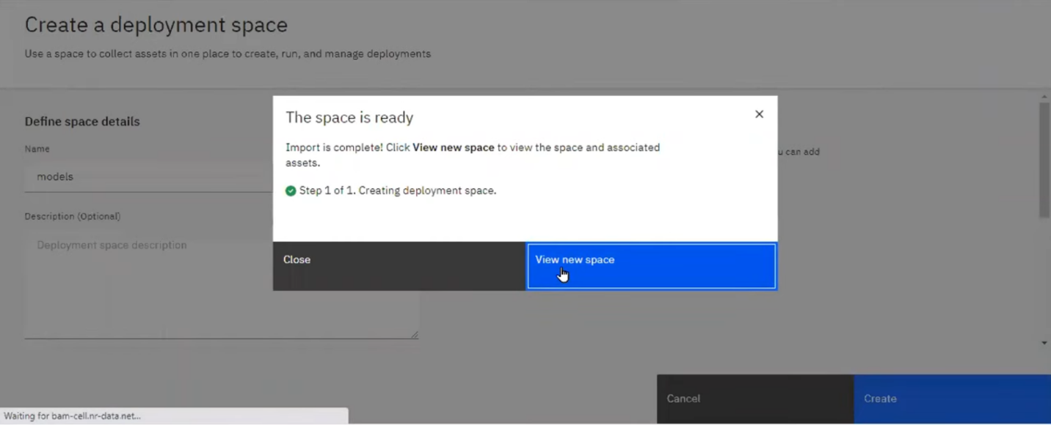

**Project Outcomes:**

**1. Model Deployment:**

- Successfully deployed the trained model as a web service on IBM Cloud Watson Studio. 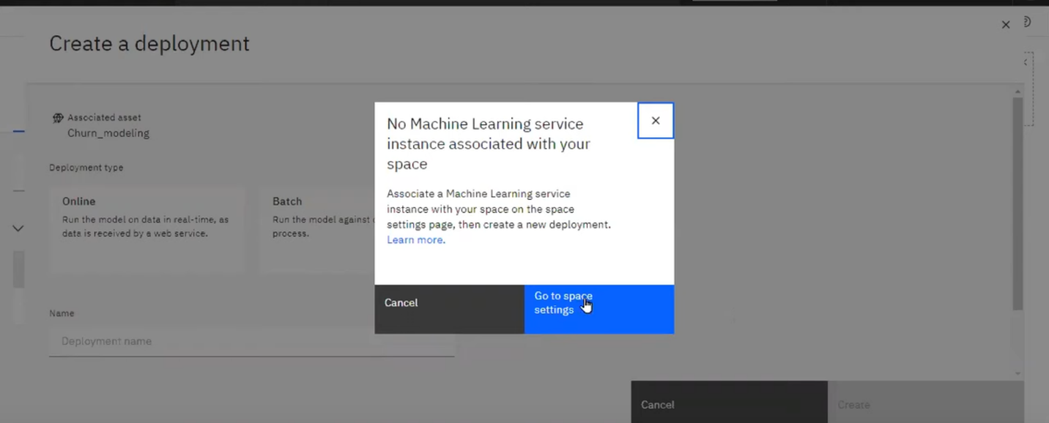

- Ensured the model is available for predictions via an API endpoint.

**2. Integration into Applications:**

- Developed one or more applications that utilize the deployed model.

- Integrated the model's predictions seamlessly into the application's user interface or business logic.

**3. Testing and Validation:**

- Conducted extensive testing to verify the functionality of the integrated model.

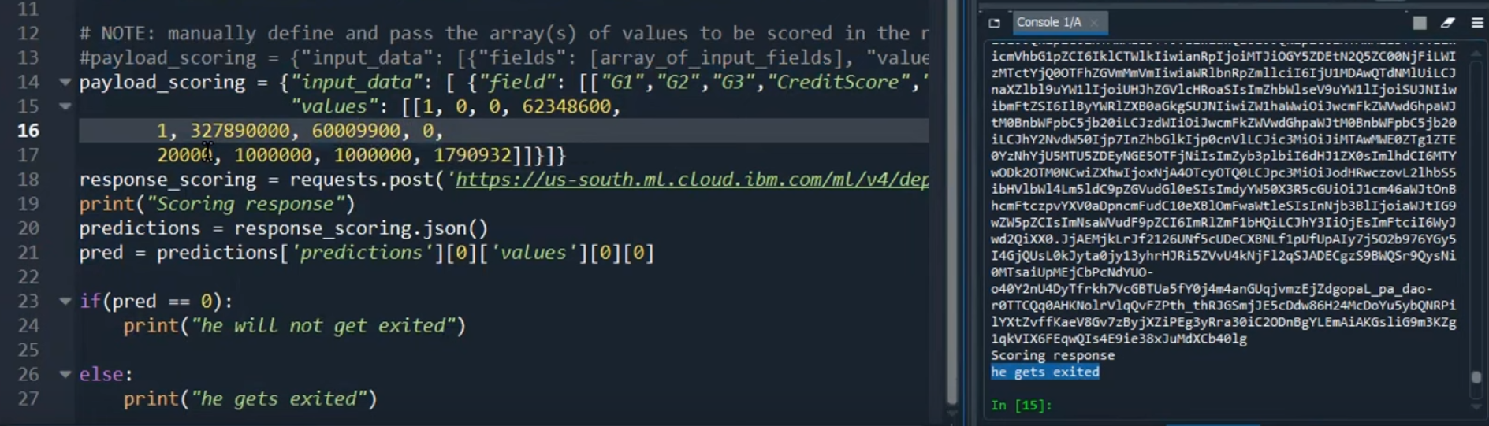

- Ensured that the model's predictions align with the application's requirements.

**Future Considerations:**

In the future, the project could be expanded or improved in the following ways:

- Continuous monitoring and updating of the model as new data becomes available.

- Implementation of robust error handling and security measures in the integrated applications.

- Scalability considerations for handling increased API traffic.

- User feedback and iterative improvements to the deployed model and applications.

**Conclusion:**

This project successfully achieved its goals of deploying a machine learning model in IBM Cloud Watson Studio and integrating it into applications through a provided API endpoint. The deployment and integration process enables real-time predictions and can be utilized in various business applications, contributing to data-driven decision-making and automation.